 | ELECTRICAL WORK ORDER  Alder Residence — Portland, OR

Customer | Casey Alder
Address | 1234 SE Alder St, Portland, OR 97215
Phone | (503) 555-0136
Questions on site | Kyle — (503) 555-0117
Job # | 2026-0714
Install Dates | ___________________________
Crew Lead | ___________________________
⚠ SAFETY FLAGS: LEAD PAINT — 1962 home, lead-safe (RRP) practices on any paint disturbance
Scope of Work
Task | Details | Location
New 240V circuit for heat pump | 25A 2-pole breaker, 10/2 from panel to east-wall disconnect, whip to ODU | Panel (garage) to east wall
Equipment Arriving
Item | Model | Qty
Outdoor unit | 24k cold-climate ductless ODU | 1
Wall heads | 12k (living) + 9k (bedroom) | 2
Bath fan | 110 CFM ENERGY STAR, humidistat | 1
Range hood | 300 CFM ducted | 1
Disconnect + whip | 60A non-fused | 1
Burch QA — Electrical
☐ New circuits sized correctly for HP + aux + HPWH (Q159)
☐ All major electrical work permitted and closed out (Q160)
☐ Panel size sufficient for load — 100A vs 200A verified (Q161)
☐ Breakers labeled at the panel
Permits
☐ Permits closed out for EACH inspected installed measure (Q162)
☐ Permit finals scheduled BEFORE requesting the program QA inspection
☐ Inspection cards / permit numbers photographed for the job file
Notes for Crew
• Homeowner is on video calls in the back office — knock at the front door, headphones mean go around
• Keep the driveway clear of material staging after 4pm (street sweeping Tuesday)
• Cat is friendly and sneaky — check for her before closing the attic hatch
Reference Photos
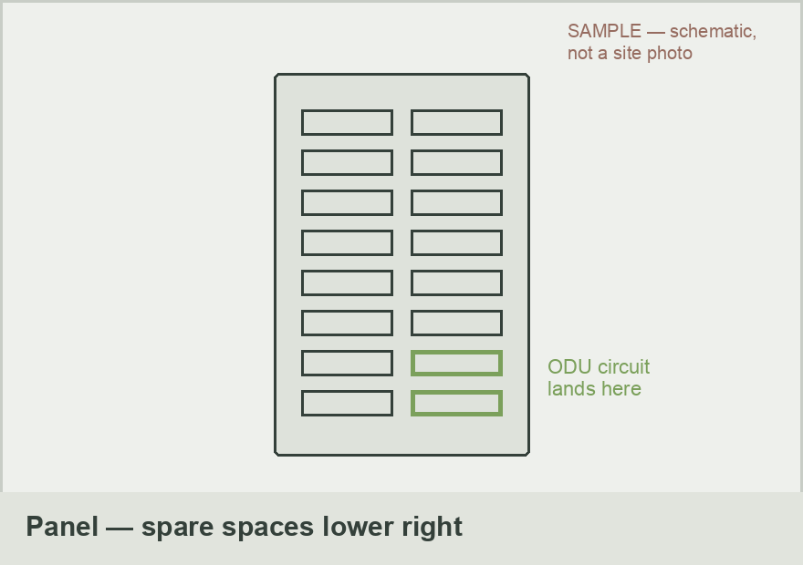 | 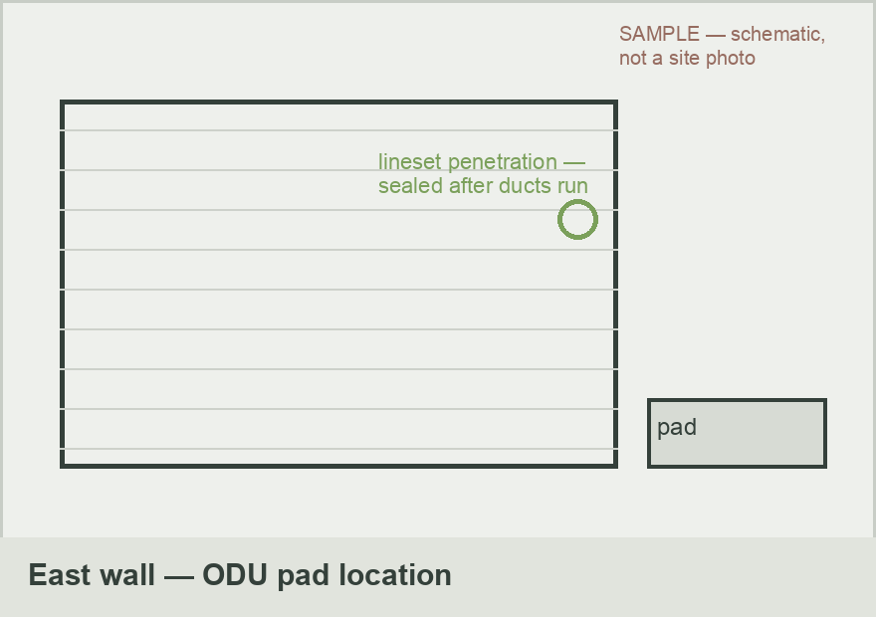
Panel in garage — ODU circuit lands in the spare spaces, lower right | East wall ODU location — pad here, lineset penetration sealed after ducts run

Resilient Retrofits · CCB# 245539 · Prepared by: Kyle Kanooth

